Packet Tracer – Investigating the TCP/IP and OSI Models

Instructions
The objective of this simulation activity is to lay down the foundations for understanding the TCP/IP protocol suite and how it relates to the OSI model. You can observe the data contents being sent over the network at each layer in simulation mode.
Data is divided into smaller portions as it travels through the network and given a name so that when it gets to its destination, it can be put back together. Each component belongs to a certain layer of the TCP/IP and OSI models and is given a unique name (protocol data unit [PDU]). You can see every layer and its corresponding PDU in the Packet Tracer simulation mode. The following steps guide the user through the process of requesting a web page from a web server using a client PC's web browser application.

Generating Web Traffic and Examining HTTP.
In your packet tracer, connect a server to a pc. Configure the server and the PC with the following IP addresses.
For the PC, click on Desktop to set the IP addresses as shown below:
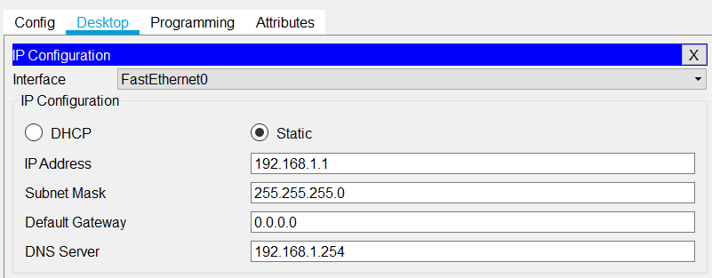
For the Server, click on Desktop to set the IP addresses as shown below:
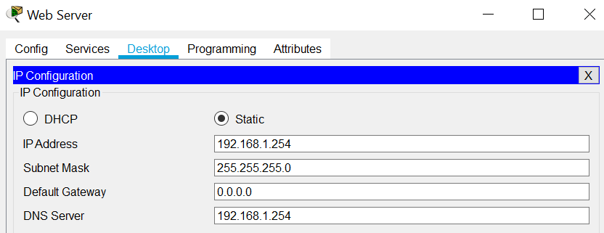

Note: “The Domain Name System (DNS) Server is a server that is specifically used for matching website hostnames (like example.com) to their corresponding Internet Protocol or IP addresses”.

Then, switch from Realtime to simulation mode. In the lower right corner of the Packet Tracer interface are buttons that toggle between Realtime and Simulation mode. In Simulation mode, packets are displayed as animated envelopes, time is event driven, and the user can step through networking events.
      - Click the Simulation mode icon to switch from Realtime mode to Simulation mode.
      - Select HTTP from the Event List Filters.
        - HTTP may already be the only visible event. If necessary, click the Edit Filters button at the bottom of the simulation panel to display the available visible events. Toggle the Show All/None check box and notice how the check boxes switch from unchecked to checked or checked to unchecked, depending on the current state.
        - Click the Show All/None check box until all boxes are cleared and then select HTTP from the Misc tab of the Edit Filters window. Click the X in the upper right-hand corner of the window to close the Edit Filters window. The Visible Events should now only display HTTP.

Currently the Simulation Panel is empty. There are five columns listed within the Simulation Panel (Vis., Time (Sec), Last Device, At Device). As traffic is generated and stepped through, events appear in the list.
To generate the HTTP traffic, the HTTP and DNS should be ‘On’ in the Server settings as below:
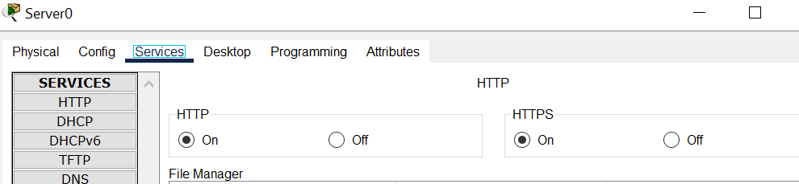

Note: If you don’t see the “Services” tab in Packet Tracer, you might need to enable it.
Go to the top bar and click Options → Preferences, then untick the box that says, “Hide Services Tab”.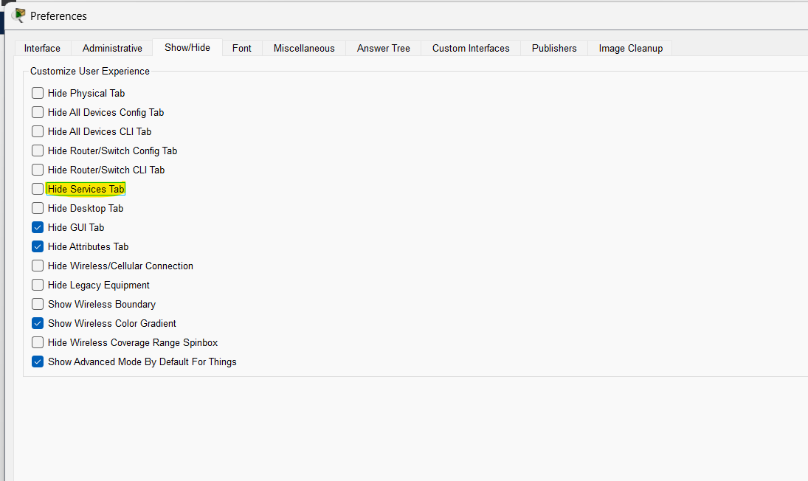
To configure the DNS service on the generic server, define names of the hosts (such as website) and their corresponding IP addresses.
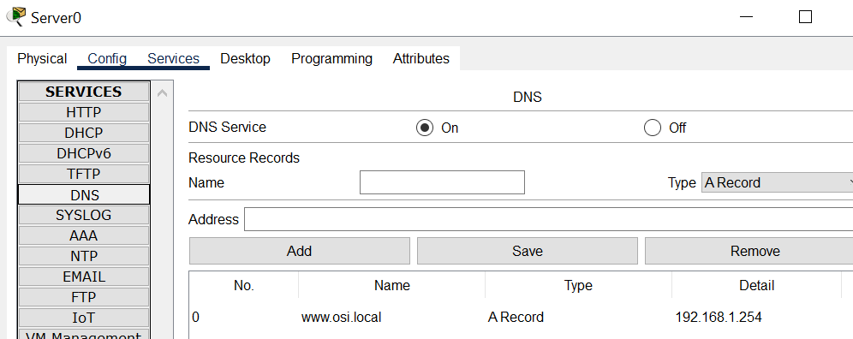

For the topology you designed:

      - Click Web Client (Desktop icon within the topology) in the far-left pane.
      - Click the Desktop tab and click the Web Browser icon to open it.
      - In the URL field, enter www.osi.local and click Go.
Because time in Simulation mode is event-driven, you must use the Capture/Forward button to display network events. The capture forward button is located at the left-hand side of the blue band that is below the topology window. Of the three buttons there, it is the one on the right.
      - Click Capture/Forward four times. There should be four events in the Event List.

Please answer the following with screenshots:
- Look at the Web Client web browser page. Did anything change?
Yes, one enough time had passed for the full HTTP transaction to be completed the browser changes from a blank loading screen to a webpage. The HTTP transaction involved the DNS look up, TCP handshake and the HTTP response.
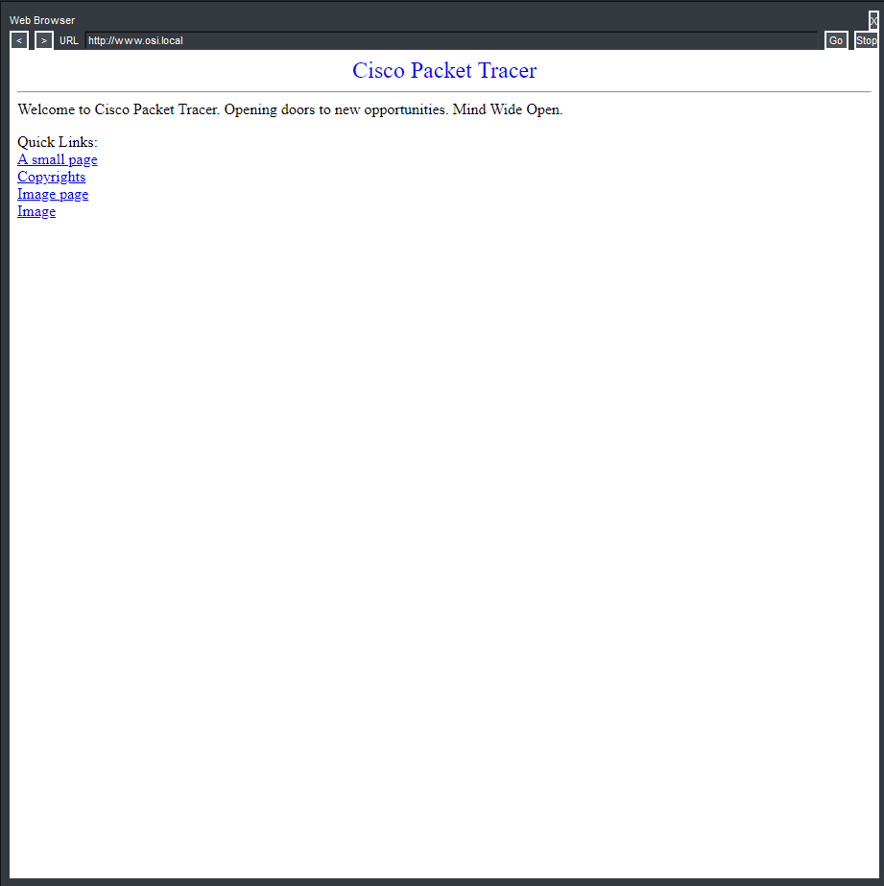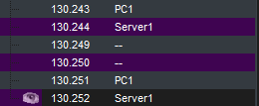
- Can you try with another URL?
I was a bit confused exactly what to do so I firstly type in www.osi.org which couldn’t be found since it was not set up in the DNS server:
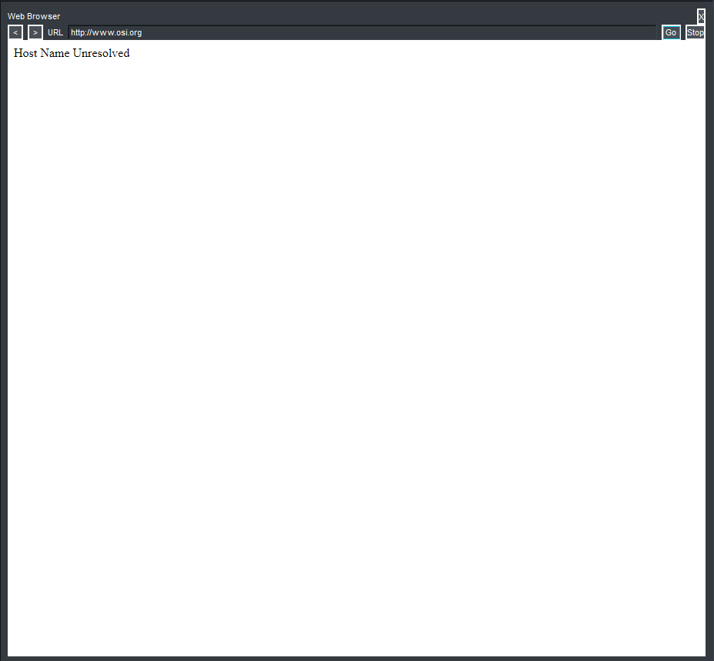
Then after that I just typed the IP of the DNS server in which skips the DNS resolution and goes straight to the webpage:
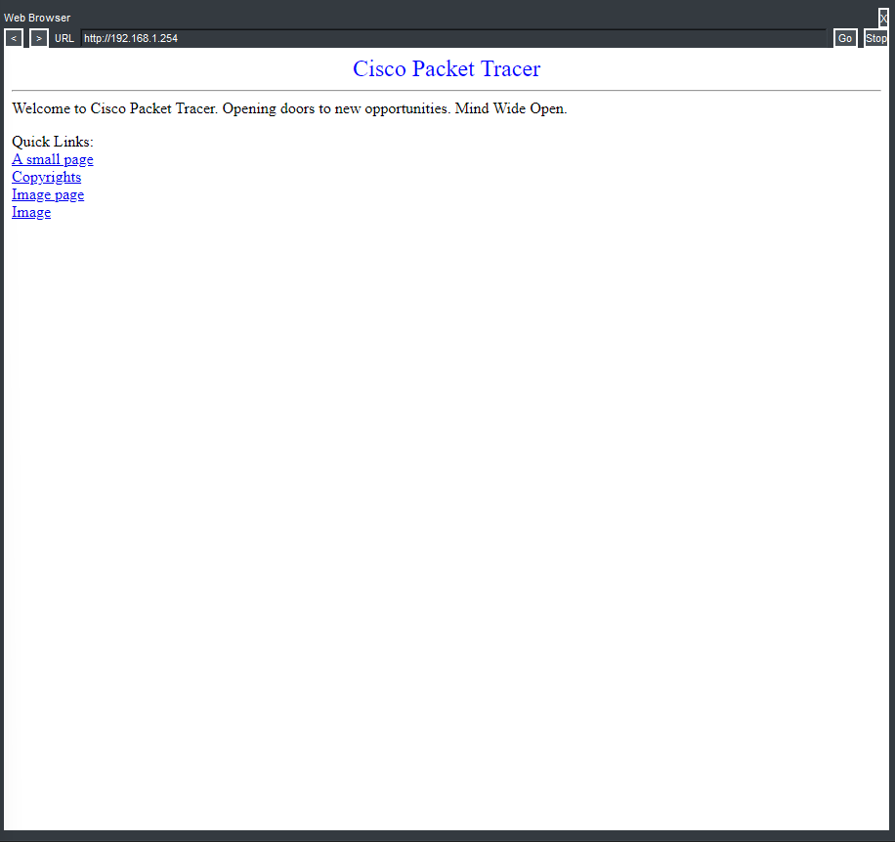

Explore the contents of the HTTP packet.

.

Explore the contents of the HTTP packet.
      - Click the first colored square box (purple box) under the Event List > Type column. It may be necessary to expand the Simulation Panel or use the scrollbar directly below the Event List.
The PDU Information at Device: Web Client window displays. In this window, there are only two tabs (OSI Model and Outbound PDU Details) because this is the start of the transmission. As more events are examined, there will be three tabs displayed, adding a tab for Inbound PDU Details. When an event is the last event in the stream of traffic, only the OSI Model and Inbound PDU Details tabs are displayed.
      - Ensure that the OSI Model tab is selected.
Under the Out Layers column, click Layer 7.

Please answer the following:
What information is listed below in the In Layers and Out Layers boxes for Layer 7? HTTP

What is the Dst Port value for Layer 4 under the Out Layers column? 1036
What is the Dest. IP value for Layer 3 under the Out Layers column? 192.168.1.1

Optional Activity
Explore the layers of a DNS packet, attached screenshots of your attempts.
